# **CTF Topic: Mail Servers**

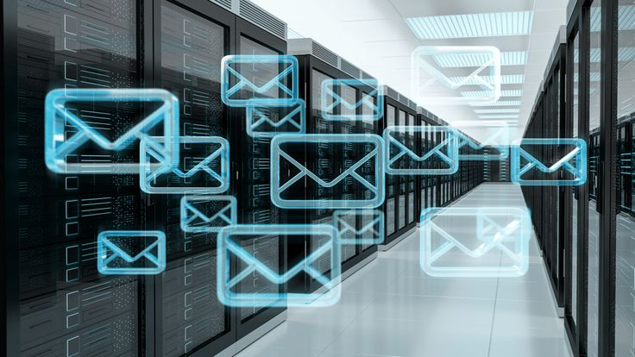

# **Introduction**

The term mail server is commonly used to refer to an email server, which is simply a software application that is designed for sending and receiving mail. Sometimes, it refers to the mail transfer agents (MTA), which is quite similar, though, to the mail delivery agents (MDA), each of which has distinctive roles.

A mail server can be described as being a system which has the responsibility of signing up for and, in some instances, redirecting an email. Without them, users cannot be able to transfer those messages to different mail clients, or download them into their inboxes.

Email messages are sent and received using two types of mail servers: the senders MTA (Outgoing mail servers) and the receptors MDA (Incoming mail servers). MTAs collect outgoing emails from the sender’s mail application, and deliver to MDAs that are vested with the role of temporarily holding and forwarding the messages to the recipient’s mail application.

While mail clients and mail servers are both used to send and receive email messages, they are not the same. A mail client is an application that allows users to retrieve, store, and format emails to be sent. Mail servers, meanwhile, are software programs that use email protocols to move email messages between mail clients.

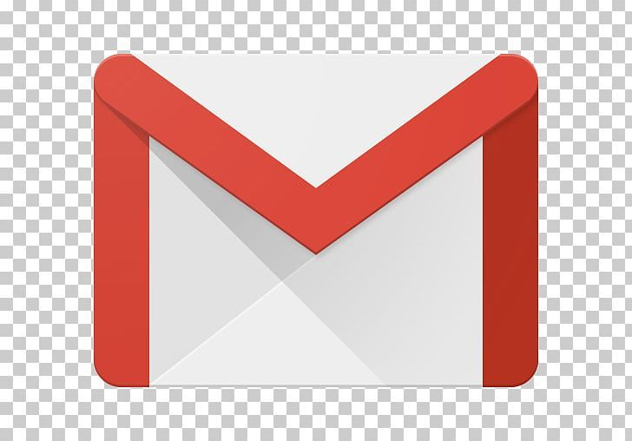

# **Let’s start the Challenge**

# **Question**

Flag 1 : What does MTA stand for ?

Answer : Mail Transfer Agents

Flag Captured

Flag 2 : What kind of mail server’s are the sender’s mail server ?

Answer : Outgoing mail servers

Flag Captured

Flag 3 : What kind of mail server is the receiver’s mail server ?

Answer : Incoming mail servers

Flag Captured